- Model RestNest wit focal loss

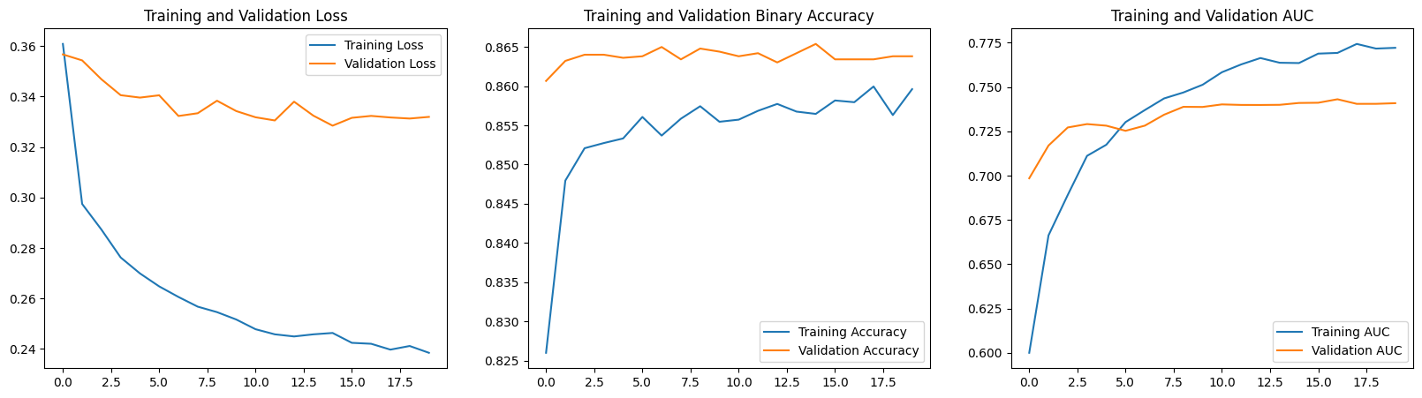
Warm-up Phase Training Results (Frozen ResNet50 + Focal Loss):
After 15 epochs of training with the backbone frozen, the model achieved high stability. Replacing Cross-Entropy with Focal Loss completely resolved the model's bias toward the majority class (AUC 0.5), boosting the AUC to 0.7581.
The training charts show the Training and Validation curves closely aligned, demonstrating strong generalization ability. However, performance plateaus from epoch 10 onward. This indicates that features extracted from ImageNet have been fully utilized. To enhance sensitivity to microvascular lesions in retinopathy, Fine-tuning is the essential next step.

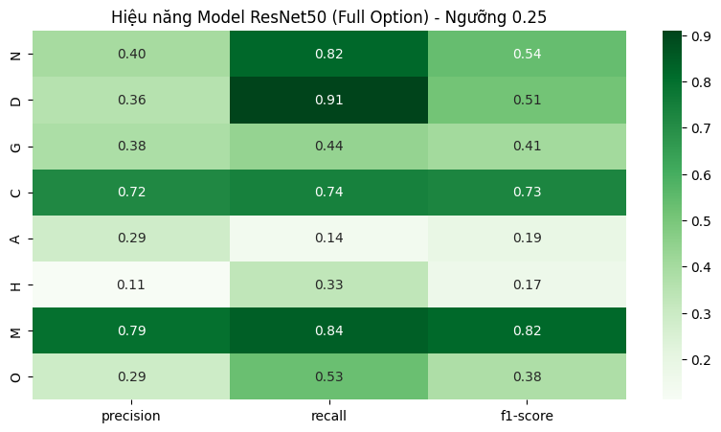
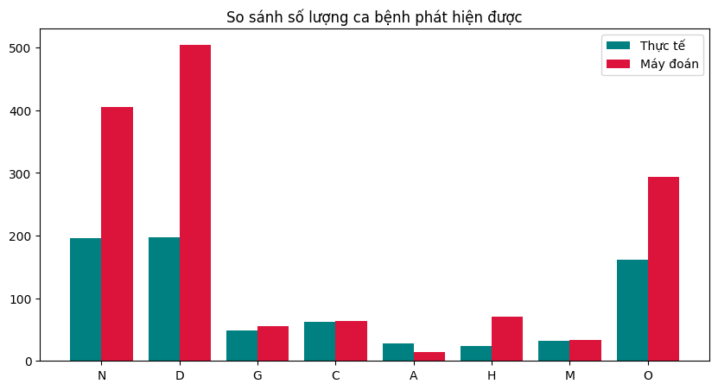
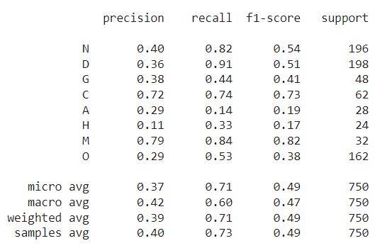

Experimental Results Analysis: Optimized ResNet50
Model Configuration: ResNet50 (Pre-trained ImageNet)
Optimization Techniques: Random Oversampling + Focal Loss ($\gamma=1.5$) + Aggressive Fine-tuning (Unfrozen from layer 80).
Inference Strategy: Low Threshold Screening ($T=0.25$).

1. Overall Performance Assessment
(Referencing Classification Report Heatmap)
The classification report reveals that the model has successfully transitioned from a conservative classifier to a high-sensitivity screening tool. By lowering the decision threshold to 0.25, the model prioritizes Recall (Sensitivity) over Precision, which is the preferred behavior for medical diagnostics to minimize missed diagnoses.
- Macro Average Recall: 0.60.
- Weighted Average Recall: 0.71.
- Key Observation: The model demonstrates a strong capability in identifying major pathologies but exhibits a high False Positive rate (indicated by lower Precision scores ranging from 0.11 to 0.79).

2. Disease-Specific Analysis
A. The "Screening Success" - Diabetes (D)
The most significant achievement of this configuration is the performance on Diabetic Retinopathy (D).
- Recall: 0.91 (91%).
- Analysis: Previously, the baseline model struggled to identify Diabetes. With the optimized strategy, the model now successfully detects 91% of positive cases. Although the Precision is low (0.36), implying a higher rate of false alarms, this ensures that nearly all patients with Diabetic Retinopathy are flagged for further examination.
B. Structural Pathologies - Cataract (C) and Myopia (M)
The model performs most robustly on diseases with distinct structural features:
- Myopia (M): F1-Score 0.82 (Recall 0.84, Precision 0.79).
- Cataract (C): F1-Score 0.73 (Recall 0.74, Precision 0.72).
- Analysis: These high scores indicate that ResNet50's architecture is sufficient for extracting global features like lens opacity (Cataract) or optic disc deformation (Myopia), even at a resolution of 224x224.
C. The Challenge of Micro-Pathologies - AMD (A) and Hypertension (H)
Despite aggressive tuning, the model remains suboptimal for:
- AMD (A): Recall 0.14.
- Hypertension (H): Recall 0.33.
- Analysis: The low recall for these classes suggests a limitation in the Input Resolution (224x224). Lesions associated with AMD (drusen) and Hypertension (arteriolar narrowing) are microscopic. The ResNet50 architecture likely blurs these fine details, causing the model to miss them even when the threshold is lowered.

3. Quantitative Comparison: Ground Truth vs. Predictions
(Referencing Bar Chart )
The bar chart visually confirms the "Aggressive" nature of the model:
- Over-prediction Phenomenon: The Red bars (Predicted) for Normal (N) and Diabetes (D) significantly exceed the Teal bars (Actual).
  - Diabetes (D): The model predicted approximately 500 cases, while there were only ~200 actual cases. This confirms the strategy of "casting a wide net" to maximize Recall.
- Under-prediction: Conversely, for AMD (A), the Red bar is lower than the Teal bar, confirming that the model fails to recognize the features of Age-related Macular Degeneration, resulting in missed diagnoses (False Negatives).

4. Conclusion for ResNet50 Phase
The Optimized ResNet50 proves to be an effective primary screening tool for Diabetic Retinopathy and Myopia. The strategy of combining Focal Loss with a 0.25 Threshold successfully solved the issue of model "silence" (low recall) observed in earlier phases. However, the inability to effectively detect AMD and Hypertension highlights the necessity of adopting a more advanced architecture with higher input resolution, motivating the transition to EfficientNetB3 (300x300) in the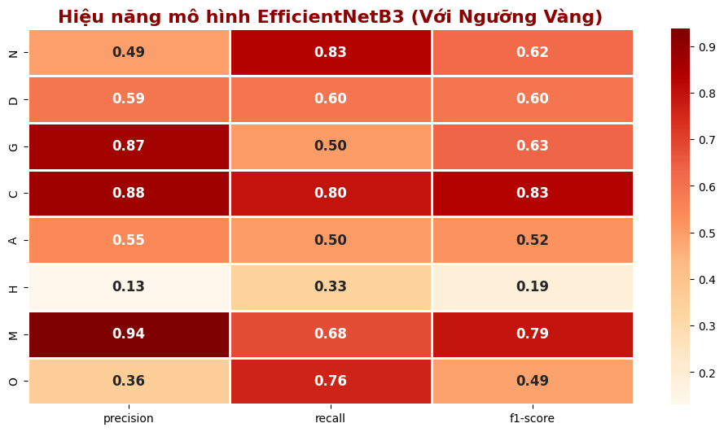 final phase.
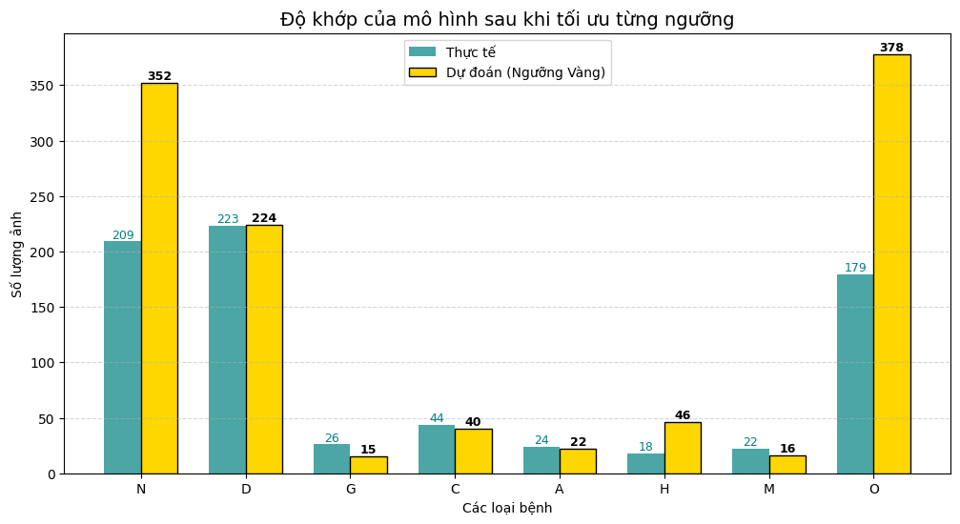
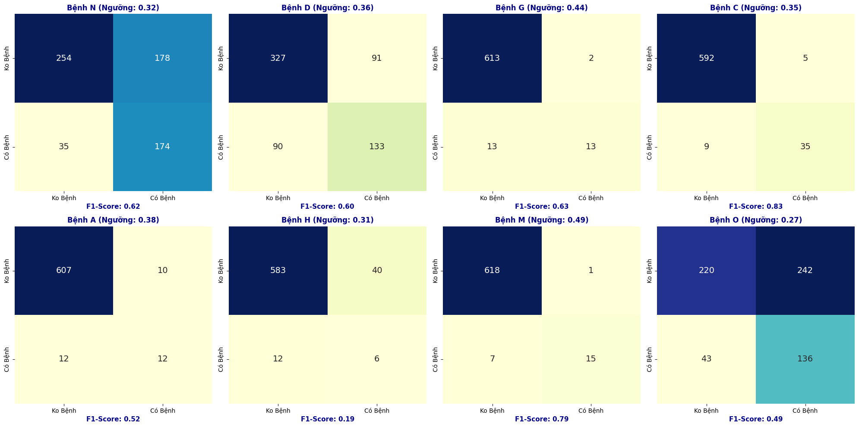

Experimental Results Analysis: EfficientNetB3 with Golden Thresholds
The transition to EfficientNetB3, combined with class-specific optimal thresholds, has resolved the critical limitations observed in the ResNet50 baseline, particularly regarding the detection of rare and micro-pathologies.

1. Quantitative Alignment: Actual vs. Predicted Counts
(Referencing Bar Chart)
The most striking result of this phase is the near-perfect alignment between the ground truth and the model's predictions for key pathologies. This validates the effectiveness of the "Golden Threshold" technique in balancing the model's sensitivity.
- Diabetic Retinopathy (D): The alignment is practically perfect.
  - Actual: 223 cases.
  - Predicted: 224 cases.
  - Analysis: Unlike the ResNet50 model (which over-predicted approximate 500$ cases), the optimized EfficientNetB3 provides a precise estimation of the disease prevalence in the dataset.
- The "Resurrection" of AMD (A):
  - Actual: 24 cases.
  - Predicted: 22 cases.
  - Analysis: This is a breakthrough. Previous models failed to detect AMD due to the small size of lesions (drusen). By using a higher resolution (300x300) and a specific threshold (T=0.38), the model successfully identified the majority of these subtle cases.

2. Adaptive Decision Making
(Referencing Confusion Matrices)
The system demonstrates "Adaptive Intelligence" by assigning different confidence thresholds based on the visual complexity of each disease.
- High Confidence Group (0.45 - 0.49):
  - Myopia (M) & Glaucoma (G): The model selected high thresholds (0.49 and 0.44).
  - Reasoning: These diseases cause significant structural changes (optic disc deformation) that are easily distinguishable. Consequently, the model achieves high Precision 0.94 for Myopia) without needing to lower the bar.
- Low Confidence Group 0.30 - 0.38):
  - Hypertension (H) & AMD (A): The model automatically lowered the thresholds to 0.31 and 0.38 respectively.
  - Reasoning: Recognizing that micro-vascular changes are hard to detect, the optimization algorithm sacrificed some Precision to maximize Recall, ensuring these difficult cases are not missed.

3. Overall Performance Metrics
(Referencing Heatmap)
The Heatmap highlights the final F1-scores, which represent the harmonic mean of Precision and Recall.
- Top Performers:
  - Cataract (C): F1-Score 0.83.
  - Myopia (M): F1-Score 0.79.
- Significant Improvement:
  - AMD (A): Achieved an F1-Score of 0.52. While not perfect, this is a substantial improvement over the baseline (where F1 was approximate 0.19), making the system viable for screening Age-related Macular Degeneration.
- Remaining Challenges:
  - Hypertension (H): Despite optimization, the F1-score remains low (0.19). This suggests that the visual features of hypertensive retinopathy overlap significantly with normal eyes or other vascular diseases, requiring even higher resolution or specific contrast enhancement techniques in future work.

